Case Information
Case ID: ra639058096351022135_-847381402
Incident Title: Attempted Lateral Movement Using Remote Logon (Contained)
Date Opened: February 4, 2026
Severity: Medium
Status: Closed – Contained
Affected Host: MTS-ContractorPC1

Executive Summary
On February 4, 2026, Microsoft Defender for Endpoint detected and blocked multiple remote authentication attempts targeting the Administrator account on the Windows endpoint MTS-ContractorPC1. The activity originated from external IP address 109[.]205[.]211[.]14, 185[.]214[.]96[.]27 and exhibited characteristics consistent with credential stuffing and attempted lateral movement.

Subsequent endpoint telemetry revealed the execution of administrative command-line tools and silent file deletion activity, suggesting potential post-exploitation cleanup behavior. Defensive controls successfully prevented account compromise and lateral spread. No persistence mechanisms or secondary host impact were identified.

Incident Scope
• Affected Device: MTS-ContractorPC1
• Affected Account: Administrator
• Source IP Address: 109[.]205[.]211[.]14, 185[.]214[.]96[.]27
• Authentication Protocol: NTLM
• Network Type: External

Timeline of Events (UTC)
13:31–13:40 – Multiple NTLM-based authentication attempts detected and blocked.
13:40–16:24 – ContainedUserLogonBlocked events recorded.
13:37 – Silent deletion of OneDriveSetup.exe via cmd.exe.
Post-activity review – No successful logon or lateral spread observed.

Technical Analysis
Authentication Analysis:
Repeated NTLM authentication attempts targeting a privileged account were observed from an external IP address. Microsoft Defender for Endpoint blocked the activity prior to session establishment.

Process Analysis:
Observed executions included cmd.exe and rundll32.exe under Administrator context. While some rundll32 executions were consistent with normal Windows operations, cmd.exe was used to perform silent file deletion in user AppData directories.

File System Activity:
The deletion of OneDriveSetup.exe from the user AppData path was performed silently, which may indicate artifact cleanup following failed access attempts.

MITRE ATT&CK Mapping
T1021 – Remote Services (Attempted)
T1110 – Brute Force / Password Spraying
T1078 – Valid Accounts (Attempted)
T1070.004 – Indicator Removal on Host

Impact Assessment
No successful authentication was confirmed.
No lateral movement to additional systems occurred.
No persistence or credential theft artifacts were detected.
Impact was limited to attempted access only.

Response Actions
• Endpoint security controls blocked remote logon attempts.
• External IP address flagged for blocking.
• Administrator account activity reviewed.
• Additional hunting queries executed for lateral movement indicators.

Recommendations
• Enforce MFA for all privileged accounts.
• Restrict NTLM authentication where feasible.
• Review and limit local administrator usage.
• Continue enhanced monitoring for repeat activity.
• Audit OneDrive and AppData modification policies.

Attached Artifacts

Remote logons for the device mts-contractorpc1 from both IPs
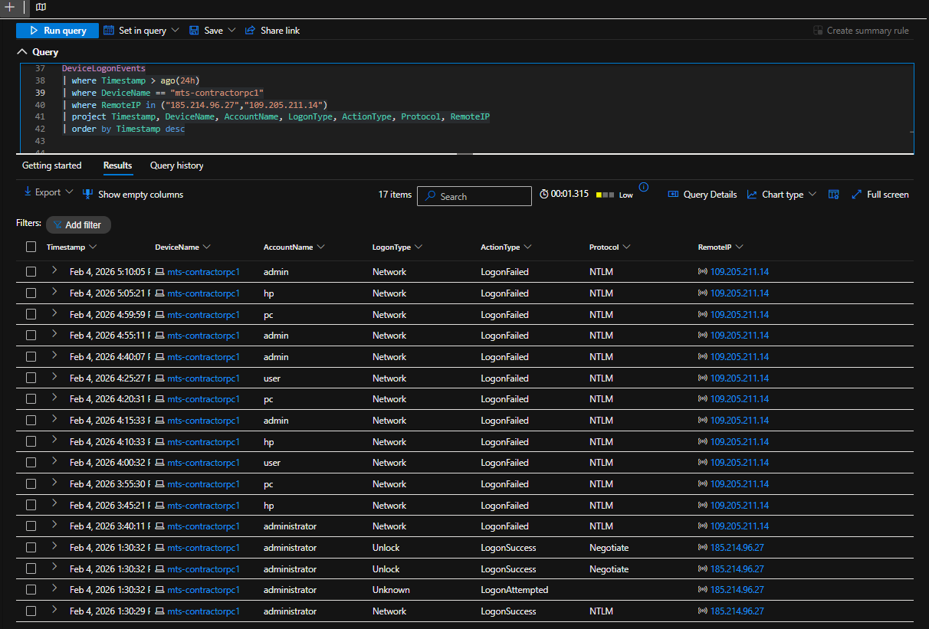

Successful remote logons
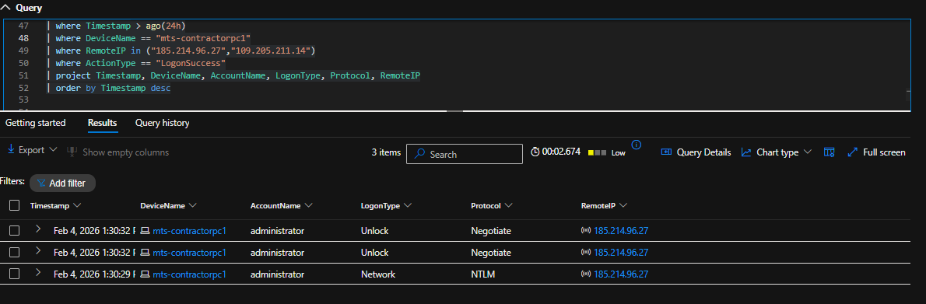

Network + RDP logons (LogonType 3 & 10)

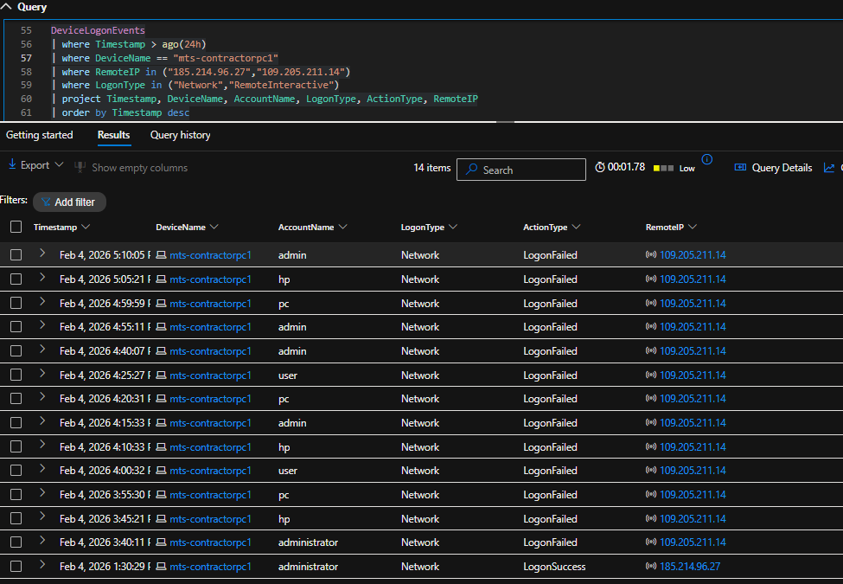

Blocked pre-authentication attempts

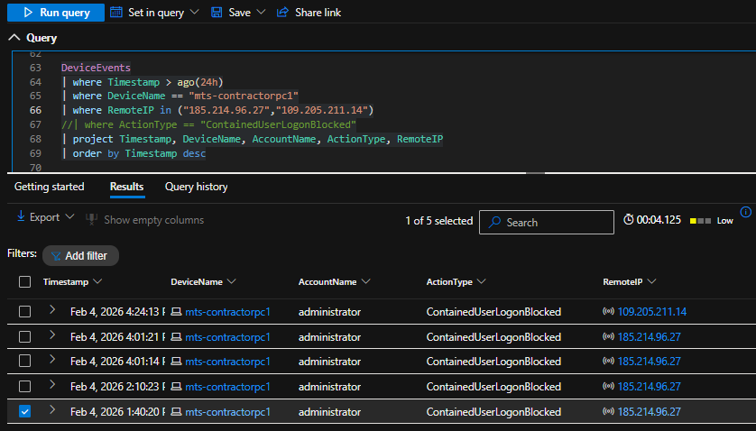

No signs of Lateral Movement
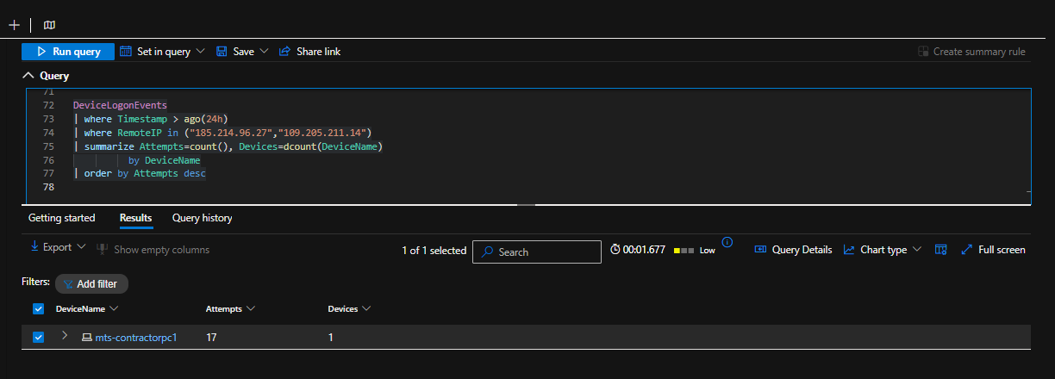

Process creation

